**Lab1: Binary Numbers**

Freddie Boadu

Ecen 328

Mansi Bhavsar

February 4,2019

**Introduction:** The purpose of this lab was to recreate a binary number using the XC3S100E device provided. The introducing schematic capture and FPGA synthesis, extra exposure to binary numbers, and learning how to use the Xilinx simulation tool to test combinational circuits was the focus of this lab. It is found that using the switches can be used to implement binary numbers as well as LEDS used to represent the decimal equivalents.

**Materials:**

* Xilinx ISE software, student or professional edition V14.7
* PC with Pentium III or higher, 128+ MB RAM and 8+ GB hard drive
* Digilent Basys2 board with an XC3S100E device.

**Methods:**

The experiment started with booting up the design program. Within in the program a 3 to 8 decoder was grabbed. Pins and locations were assigned to each of the inputs and outputs of the decoders. The schematic was then loaded into the device. It was used to make a binary number with a decimal representation on the LEDS.

First step was to put the decoder on the schematic. 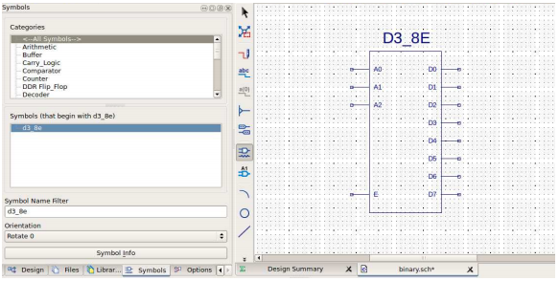

Second stop is to assign the pins to outputs and inputs

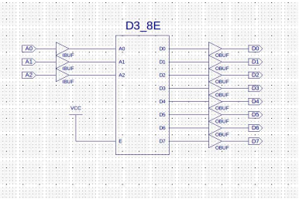

Last step is to synthesize and test the program

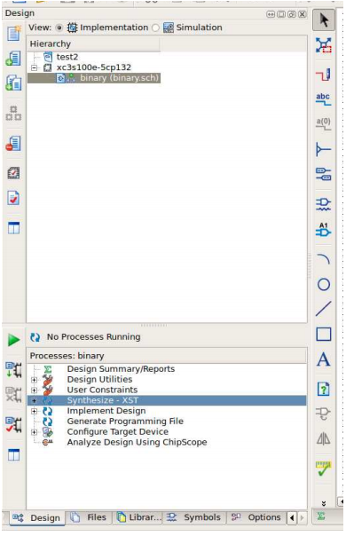

**Data:** 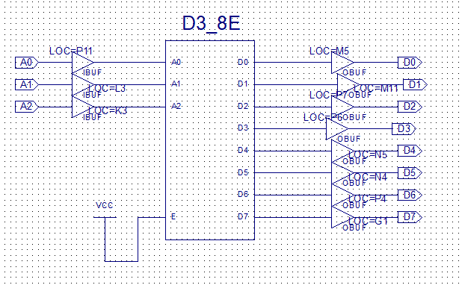

**Results:** Data shows what the schematic that was represented within the device used for the lab. The device lit up based on switches were flipped. For example, Sw0, Sw1 being flipped while Sw2 is down will show LED 3 to light up on the device. There were no mistakes or improvements to be made on this experiment.

**Conclusion:** A schematic was made to represent a binary number and using the LEDS on the device provided it showed a decimal equivalent of that number. The data collected shows the schematic that allowed the project to be displayed, contained pins and locations in relation to the board which allowed it to make a fully functional binary number.